**Hull City Council**

**Children’s Services**

**EU Settlement Scheme – Children’s Services**

**February 2024**

**Version Control and Publication Information**

|  |  |
| --- | --- |
| **Approvals** | |
| Document Author |  |
| Policy Consultation |  |
| Approval: | Date:  Approved by: |
| Policy Implementation / Published |  |
| Version |  |
| Date of next review |  |

|  |  |  |  |
| --- | --- | --- | --- |
| **Version Control** | | | |
| Version Number | Key Changes Made | Signed Off By | Issue Date |
| 1.0 | New policy |  |  |

**Table of Contents**

1. Purpose of the Policy 4
2. Legal and Policy Context 4
3. Introduction 4
4. Determining Eligibility 5
5. Children with a care order, interim care order or placement order 6
6. Accommodated Children 7
7. Any other children in receipt of WCBC Support 7
8. Care Leavers 8
9. Youth Secure Settings (Under 18) 8
10. Data Recording 9
11. Appeal Rights and Administrative Review 10
12. Appendix 1 – EUSS Process Flowchart 11
13. Appendix 2 – EUSS Notification Form 12

# Purpose of the Policy

To ensure that all looked after children and care leavers, who are EU, other European Economic Area (EEA) or Swiss citizens, make an application to the EU Settlement Scheme.

# Legal and Policy Context

* + [Borders, Citizenship and Immigration Act 2009](https://www.legislation.gov.uk/ukpga/2009/11/contents)
  + [Care Leavers Regulations 2010](https://www.legislation.gov.uk/uksi/2010/2571/made)
  + [Children and Social Work Act 2017](https://www.legislation.gov.uk/ukpga/2017/16/part/1/chapter/1/crossheading/care-leavers-in-england)
  + [EU Settlement Scheme - Looked-after children and care leavers: local authority and health and social care trust guidance 2020](https://assets.publishing.service.gov.uk/government/uploads/system/uploads/attachment_data/file/918663/looked-after-children-EUSS.pdf)
  + [EU Settlement Scheme: EU, other EEA and Swiss citizens and their family members guidance](https://assets.publishing.service.gov.uk/government/uploads/system/uploads/attachment_data/file/953873/main-euss-guidance-v9.0ext.pdf)
  + [EU Settlement Scheme Communications Toolkit](https://www.gov.uk/government/collections/eu-settlement-scheme-community-groups-toolkit)
  + [EU Settlement Scheme – Introduction for Local Authorities](https://assets.publishing.service.gov.uk/government/uploads/system/uploads/attachment_data/file/924363/HO_EUSS_Local_Authorities__Introduction.pdf)
  + [Children’s Services Policy 1.20 Advocacy](https://intranet.wrexham.gov.uk/sites/default/files/2021-03/CSC%20Policy%201.20%20Advocacy%20v1.2.pdf)

# Introduction

* 1. The EU Settlement Scheme allows EU citizens resident in the UK by 31 December 2020, and their family members, to get the immigration status they need to continue to live, work and study in the UK beyond 30 June 2021. This status means they will continue to be eligible for public services, such as healthcare and schools, as well as public funds and pensions. They will also be eligible for British citizenship, if they meet the requirements and want to apply.
  2. Under the EU Settlement Scheme, there are a number of statutory obligations placed on Hull City Council Children’s Services. These include:
     + Identifying adequately trained resource to manage and make applications.
     + Identifying eligible children, including looked after children for whom the HCC has parental responsibility, looked after children who are accommodated, care leavers and any other children in receipt of local authority support, for example children in need.
     + Identifying key signposting responsibilities towards each eligible child and putting plans in place to ensure this signposting support takes place.
     + Determining, for each child HCC has parental responsibility for, whether we will be applying online and whether we can use the EU Exit: ID Document Check app or will be posting the child’s identity document to the Home Office to be checked and returned.
     + Keeping an adequate record of each application made, including the status granted and which email address and phone number were used.
     + Recording plans for monitoring the child’s status, including future actions, with deadlines, to be carried out, in order, where the child is granted pre-settled status (generally where they been continuously resident in the UK for less than five years), to apply to convert this to settled status at the appropriate time in the child’s care plan or the care leaver’s pathway plan.

# Determining Eligibility

* 1. Determining eligibility for the EU Settlement Scheme is the responsibility of the child’s case holding Social Worker or the young person’s Personal Adviser (where the young person is accessing a Leaving Care Service).
  2. Staff should refer to the [EU Settlement Scheme: EU, other EEA and Swiss citizens and their family members’ guidance](https://assets.publishing.service.gov.uk/government/uploads/system/uploads/attachment_data/file/953873/main-euss-guidance-v9.0ext.pdf) to assist with identifying which children / young people are in scope of the EU Settlement Scheme.
  3. Before making an application to the EU Settlement Scheme on behalf of a looked after child, the case holding Social Worker should consider whether the child might be a British citizen. If they are, they are not eligible for the scheme. To check whether a child is a British citizen, please refer to the following guidance: [https://www.gov.uk/check- british-citizenship.](https://www.gov.uk/check-british-citizenship) It is important to consider this guidance and what is – or will be – in the best interests of the child in relation to any application for British citizenship. Advice can be sought from HCC Legal Services to support with this.
  4. At this point, the staff member supporting the child / young person should ensure that consideration is given to the child / young person’s wishes and feelings and ensure that the child / young person is aware of their right to access independent advocacy support. See [Children’s Services Procedures - Advocacy](https://hullchserv.proceduresonline.com/p_advocacy.html?zoom_highlight=advocacy) for more information.

#### For complex cases, such as cases where there are eligibility issues for non-EEA national children of EEA citizens, where the child resides on the basis of a derivative right of residence under EU law, where non EU / EEA / EFTA parents of the child could come to the UK and care the child, or where British citizenship can be applied for, the case holding Social Worker or the young person’s Personal Adviser must discuss with the Team Manager and request advice from HCC Legal Services. HCC Legal Services may choose to seek independent legal immigration advice to support with the application process.

* 1. Complex cases where legal advice is needed, must be raised with Head of Service and the Assistant Director of Children’s Services must be informed.
  2. Verifying the applicant’s identity and nationality is a key requirement of the EU Settlement Scheme. If a child or young person does not have a valid passport or national identity card (for EEA citizens) or a valid passport or Home Office-issued biometric residence card or biometric residence permit (for non-EEA nationals) confirming their identity and nationality, it is important that the case holding Social Worker or the young person’s Personal Adviser endeavours to obtain a passport or national identity card for the child or young person from the authorities of their country of origin before an application to the scheme is made. In cases where HCC is unable to obtain or produce the required identity document due to circumstances beyond our control or to compelling practical or compassionate reasons, the Home Office will accept alternative evidence of identity and nationality in such cases. Further information can be

found in the EU Settlement Scheme: EU, other EEA and Swiss citizens and their family members guidance which is available here: [https://www.gov.uk/government/publications/eu-settlement-scheme-caseworker-](https://www.gov.uk/government/publications/eu-settlement-scheme-caseworker-guidance) [guidance](https://www.gov.uk/government/publications/eu-settlement-scheme-caseworker-guidance)

* 1. If a child or young person does not have the required identity document and there are circumstances beyond their control or compelling practical or compassionate reasons why it is not possible to obtain or produce one, the Social Worker / Personal Adviser will need to make the application using a paper application form. You must contact the Home Office Settlement Resolution Centre (SRC) which will confirm whether a paper application form is necessary and ensure that the correct form, if applicable, is issued. For contact details please see the [EU Settlement Scheme - Looked-after children and care leavers: local authority and health and social care trust guidance 2020.](https://assets.publishing.service.gov.uk/government/uploads/system/uploads/attachment_data/file/918663/looked-after-children-EUSS.pdf)

A request for a paper application form should include details such as the name, nationality and date of birth of the child or young person, and details of why a paper application form is required rather than using the online form. You will also need to state why you are requesting the form on behalf of a child – i.e. that HCC has parental responsibility for them. The paper application form will be uniquely coded, and therefore will only be for use in respect of the child or young person for whom it was issued.

* 1. The Home Office has developed a [toolkit](https://www.gov.uk/government/collections/eu-settlement-scheme-community-groups-toolkit) to assist staff with materials and information to help them with supporting EU citizens to apply to stay in the UK.

4.10 Independent Reviewing Officers and CP Conference Chairs (IROs / ICROs) are expected to undertake checks in Children Looked Reviews, Child Protection Conferences and Pathway Plan Reviews to ensure that eligibility for and applications to the EU Settlement Scheme have been made. If the IRO determines that the Social Worker has not completed the required steps, the IRO must escalate to the Team Manager through the [HCC IRO escalation process](https://hullchserv.proceduresonline.com/p_icro_escalation.html?zoom_highlight=pre+escalation)

# Children with a care order, interim care order or placement order

* 1. If the child is looked after under an interim care order under s.31 of the Children Act 1989 or a care order under s.38 of the Children Act 1989, or if the child is subject to a placement order under s.21 of the Adoption and Children Act 2002 and HCC has parental responsibility for the child, HCC have the responsibility for ensuring that the application is made. It is the responsibility of the case holding Social Worker to make the application.
  2. In cases where the child is placed in a Special Guardianship Order placement and the carer is an EU National, other European Economic Area (EEA) Citizen or Swiss Citizens, the case holding Social Worker must provide support and assistance to the carer to complete the application. This will include signposting the carer to relevant information. The Home Office has developed a [toolkit](https://www.gov.uk/government/collections/eu-settlement-scheme-community-groups-toolkit) to assist staff with materials and information to help them with supporting EU citizens to apply to stay in the UK.

# Accommodated Children

* 1. If the looked after child is accommodated under s.20 of the Children act 1989, HCC does not have parental responsibility for the child.
  2. The case holding Social Worker should ensure that the child and those with parental responsibility for that child are aware of the need to make an application to the scheme, signpost them to the scheme, explain why it is important to apply and offer practical support where needed.
  3. The case holding Social Worker should ensure that they work closely with the person with parental responsibility to monitor the progress of any application made, providing practical support as appropriate.
  4. A child does not require consent from their parent or guardian in order to apply. They can make their own application. It is important therefore that all eligible looked after children are aware of their eligibility to apply and that decisions are made in the child’s best interests. Where a child in the UK makes an application under the EU Settlement Scheme in their own right and which does not list a related application by a parent or guardian, there is a duty on the Home Officer to carry out checks to ensure the safeguarding of that child. For more information see: [EU Settlement Scheme: EU, other EEA and Swiss citizens and their family members guidance](https://assets.publishing.service.gov.uk/government/uploads/system/uploads/attachment_data/file/953873/main-euss-guidance-v9.0ext.pdf)
  5. In cases where the child is being accommodated because there is no-one with parental responsibility for the child or the child is lost or abandoned, the case holding Social Worker in consultation with their Team Manager will need to consider carefully how best to safeguard and promote the welfare of that child in accordance with duties set out under s.20 of the Children Act 1989.
  6. For children in foster placements, the Fostering Supervising Social Worker should offer support to Foster Carers to ensure that they are enabled to support and assist the children in their care to receive the best possible outcomes.

# Any other children in receipt of HCC Children’s Services Support

* 1. If other eligible children receiving support are identified, for example children with care and support needs or those in the Child Protection arena, the scheme should be promoted to them. Staff supporting the child & family are expected to provide support and assistance to complete the application process, this includes signposting the child / young person and their family to relevant available support.
  2. In relation to unaccompanied asylum-seeking children, there are guides for social workers and foster carers here: [Care of unaccompanied migrant children and child victims of modern slavery: Statutory guidance for local authorities (publishing.service.gov.uk)](https://assets.publishing.service.gov.uk/media/5a823a6e40f0b6230269b850/UASC_Statutory_Guidance_2017.pdf)

# Care Leavers

* 1. As per legislation and guidance, local authorities have a responsibility to provide ongoing support to young people who qualify for leaving care support up to the age of 25 in relation to the [Care Leavers Regulations 2010](https://www.legislation.gov.uk/uksi/2010/2571/made)
  2. Ensuring that care leavers secure a status through the EU Settlement Scheme is relevant to these existing statutory responsibilities.
  3. Acknowledging that there may be occasions when extra support is necessary, the Leaving Care Team should identify care leavers who may be eligible to apply to the scheme and offer them support to ensure that they make an application.
  4. In some cases, if deemed more appropriate due to their age and maturity, the Leaving Care Team may signpost them to make their own application or may need to offer practical support.
  5. Identifying the support that can be provided to help eligible young people to make an application to the scheme and keeping an adequate record of applications made and status granted should form part of the necessary pathway planning for care leavers ordinarily carried out by the Leaving Care Team in discharge of their duties.
  6. In the case of a pre-settled status outcome, plans for applying to convert this into settled status, including the deadline for doing so, must be documented in the care leaver’s pathway plan.
  7. In the event of a request for further information or a refusal decision, the Leaving Care Team should follow this up with the care leaver in a timely fashion to ensure the best possible outcomes are achieved for the individual. Activities may include contacting the Home Office (UK Visas and Immigration) via the Settlement Resolution Centre on their behalf, and/or seeking independent legal advice for or with the individual.
  8. Consideration should be given as to whether to engage an independent immigration adviser. An immigration adviser can advise whether legal aid funding via the exceptional case funding scheme may be available to cover the cost of immigration advice.
  9. All issues relating to immigration status and ongoing monitoring should be included in detail in the care leaver’s pathway plan.

# Youth Secure Settings (Under 18)

* 1. Children and young people in youth secure settings (young offender institutions, secure training centres, secure children’s homes and secure schools (once opened)) who are EEA citizens or family members of EEA citizens, may be eligible to apply for the scheme.
  2. Where parental responsibility lies with the child or young person’s legal parents, they should be completing applications on their behalf. However, HCC still have a responsibility to raise awareness of the application process to family members so they can make informed decisions; the level of involvement required will need to be assessed on a case by case basis.
  3. All looked after children in the youth justice system will require additional support. Where parental responsibility lies with HCC , the case holding Social Worker is responsible for ensuring that applications for status under the EU Settlement Scheme are submitted.
  4. Alternatively, the case holding Social Worker can support the child or young person to make their own application.
  5. If the case holding Social Worker or Personal Adviser is supporting a child or young person involved in the criminal justice system, the case must be discussed with the Team Manager and Youth Justice Service (YJS). If needed, advice can be sought from HCC Legal Services. Where legal advice is sought it must be raised with Head of Service and the Assistant Director of Children’s Services must be informed. In some cases, HCC Legal Services may then request independent immigration legal advice. These cases can be complex, so may require expert assistance to ensure the best possible outcomes.

# Data Recording

* 1. When you make an application on behalf of a looked after child, or if you otherwise signpost or support someone to make an application for a looked after child or care leaver, record keeping and recording is essential. For any child eligible, case holding Social Worker or Personal Adviser must record essential information on the [EUSS Notification Form](http://www.internal.wrexham.gov.uk/wordpress/sam/departments/social-care/childrens-social-care/social-care-toolkit/forms/) (also see appendix 2) and attach to the child’s HCC LCS record
  2. For Unaccompanied Asylum Seeking children, the case holding Social Worker or Personal Adviser must record the child’s immigration status under “Other Demographic Details” on the child’s HCC LCS record.
  3. For all other children where an EU Settlement Scheme application is being made, the case holding Social Worker or Personal Adviser must record the status of EUSS within the child’s HCC LCS record under “Other Demographic Details.” This recording will ensure these cases can be tracked and updated, as necessary and in accordance with Home Office guidance.
  4. For all EUSS applications made, the child’s case holding Social Worker or Personal Adviser must ensure the child’s Nationality is recorded on their HCC LCS case file. This recording is done on the Identity screen.
  5. Detailed records and plans for monitoring the child’s status, including future actions with deadlines, to be carried out in order to convert pre-settled status into settled status once the child or care leaver has accrued five years’ continuous residence should be documented in the child’s care and support plan or the care leaver’s pathway plan.

The child’s HCC LCS record should be uploaded with a EUSS Notification Form which records essential information regarding this application. The purpose of this form is to ensure continuity of information in the event of case transfer or change in allocated social worker/Personal Advisor. The following information is essential to record:

* + - The Unique Application Number (UAN) given when the application is made.
    - The e-mail(s) and phone number(s) that were entered in the application form.
    - The address that was entered in the application form.
    - The answers that were given to the memorable questions at the end of the application form.
    - The nationality of the child or care leaver.
    - The status the child or care leaver was granted.
    - The date that the child or care leaver can apply to convert their pre-settled status into settled status, and the date their pre-settled status expires (required only for those granted pre-settled status).

# Appeal Rights and Administrative Review

11.1 Some decisions under the EU Settlement Scheme can be challenged by an internal administrative review and/or an appeal. The decision letter will tell you whether there is the right to apply for an administrative review or to appeal and will provide links to further information on the process and the fees payable:

#### [https://www.gov.uk/guidance/eu-settlement-scheme-apply-for-an-administrative-](https://www.gov.uk/guidance/eu-settlement-scheme-apply-for-an-administrative-review) [review](https://www.gov.uk/guidance/eu-settlement-scheme-apply-for-an-administrative-review)

#### <https://www.gov.uk/immigration-asylum-tribunal>

# Appendix 1 – EUSS Process Flowchart

Hull CC Children’s Services Flowchart documents the EUSS Process. Please follow the steps outlined below:

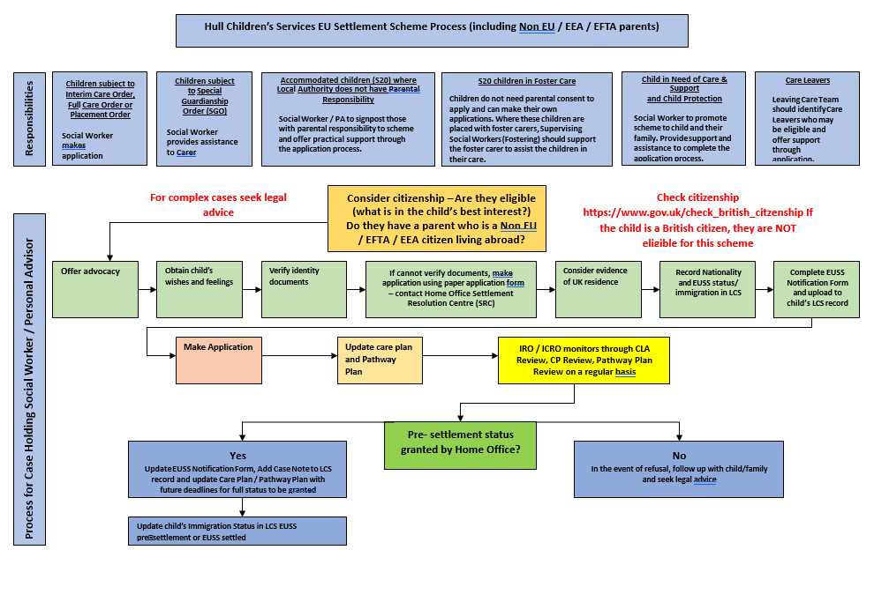

# Appendix 2 – EUSS Notification Form

# EUSS Notification Form

Please refer to the EUSS Flowchart for the EUSS application procedure. This form to be used for any applications being made and should be updated regularly with progress, date for review and outcome. The EUSS Notification Form should be scanned and attached to the child’s HCC LCS record.

**Basic Details**

|  |  |
| --- | --- |
| Child’s Name |  |
| DOB |  |
| LCS PID |  |
| Nationality |  |
| Immigration Status |  |
| Gender |  |
| Ethnicity |  |

**Responsibilities**

|  |  |
| --- | --- |
| Person(s) with Parental Responsibility |  |
| Child’s Legal Status (if applicable) |  |
| Allocated Social Worker or  Personal Advisor |  |
| Allocated Team |  |

**EUSS Application Details**

|  |  |
| --- | --- |
| Unique Application Number  *This will be given when you file the application with Home Office |  |
| Address entered in the application form |  |
| Email address given in the application form |  |
| Phone numbers given in the application  form |  |
| Memorable Questions (answers)  *please make note of the answers given to the memorable  questions during the application process |  |

**Next Steps**

|  |  |
| --- | --- |
| Status Child or Care Leaver was Granted |  |

|  |  |
| --- | --- |
| Date this status was granted |  |
| If child has been granted pre-settled status, what date can they apply for settled status? |  |
| What date does the child’s pre-settled status expire? |  |

**Once pre-settled or settled status has been granted, Allocated Social Worker or Personal Advisor should update WCCIS/CareDirector (Immigration Status) with:**

* **EUSS Pre-Settled**
* **EUSS Settled**

### Worker completing this form:

### Date Completed:

## PLEASE SCAN AND ATTACH TO CHILD’S HCC LCS RECORD